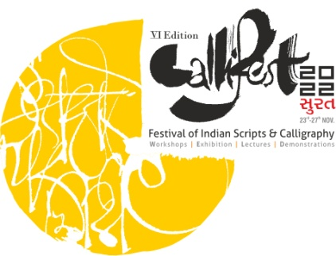

Details of Artist

Date:

Name
Nationality
Date of Birth
Full Postal Address
Email Id
Contact Number

Sr No. | Selected Theme | Name of Artwork /Installation | Type of work /  ( Materials Used) | Sizes in Inches | Image of the Artwork / Installation | Price (INR)

Note:
- Please enclose the Artwork Description, if any to be included in the Callifest Catalogue.
- Email this form to us on callifest2022@gmail.com
- Share Bank Details for the Post sale Procedure if your artwork gets sold during the exhibition period
Account Holder’s Name, Bank Name, Branch, A/c Number, Mention if it’s a savings or Current A/c, IFSC Code

